**CS 309, Team B4**

**Screen Sketch Assignment**

Group Members :

Todd Wegter

Curtis Ullerich

Brandon Maxwell

Yifei Zhu

Actors' use cases:

* Directors
* Student Staff
* Students

1_Main_CheckIn

Sketch: Todd Wegter

Annotations:

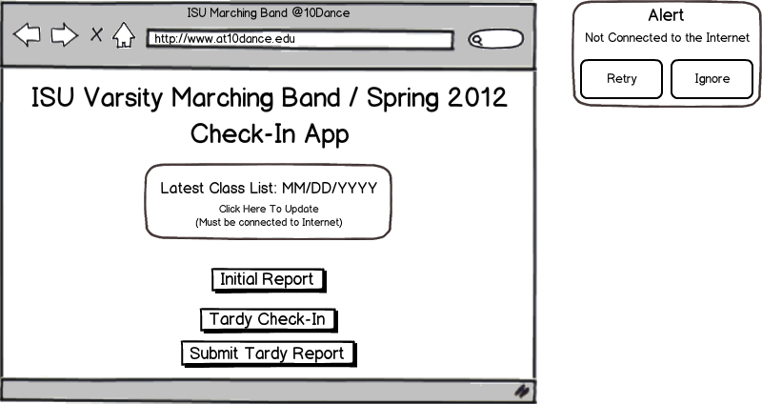

2_Initial_Report

Sketch: Todd Wegter

Annotations:

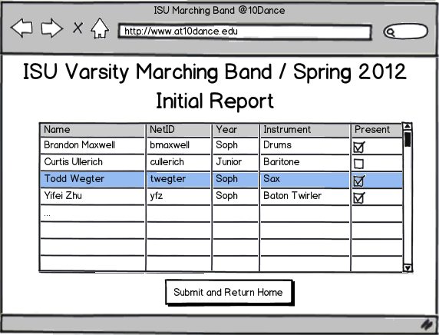

3_Late_CheckIn

Sketch: Todd Wegter

Annotations:

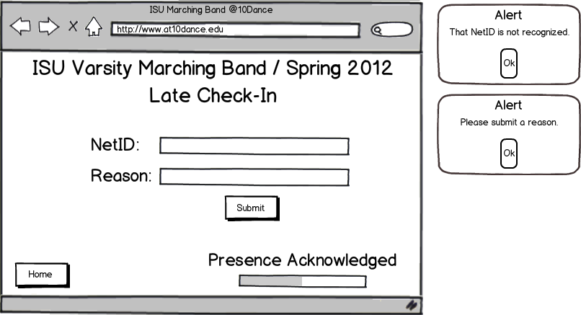

4_Main_Page

Sketch: Todd Wegter , Yifei Zhu

Annotations: Todd Wegter

3. Next Button

2. Help Button

1. Login Type Selector

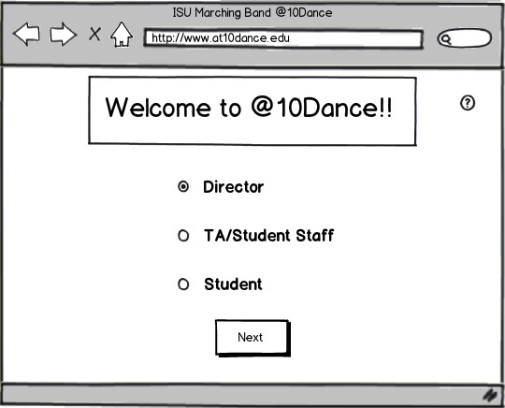

This is the main screen for the web application portion of the system. This web application is the main part of the system. It allows students to check their attendance records, TAs to upload attendance, and the directors supreme control over everything.

This screen is the first screen that users will see when accessing the application. It allows them to select whether they wish to proceed as a Director, TA, or Student by using the Login Type Selector radio buttons (1) and clicking the Next Button (3). The Next Button (3) takes the user to a login screen (Screen 5_Login), which is slightly different for the different user types and allows only the selected type to login.

Clicking the Help Button (2) will pull up a specialized Help screen (Screen 27_Help) explaining that the user may proceed to the desired login screen by selecting the appropriate radio button (1).

5_Login

Sketch: Todd Wegter, Yifei Zhu

Annotations:

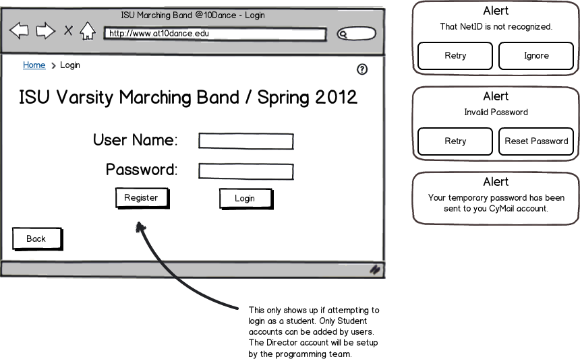

6_Login_Registration

Sketch: Todd Wegter

Annotations:

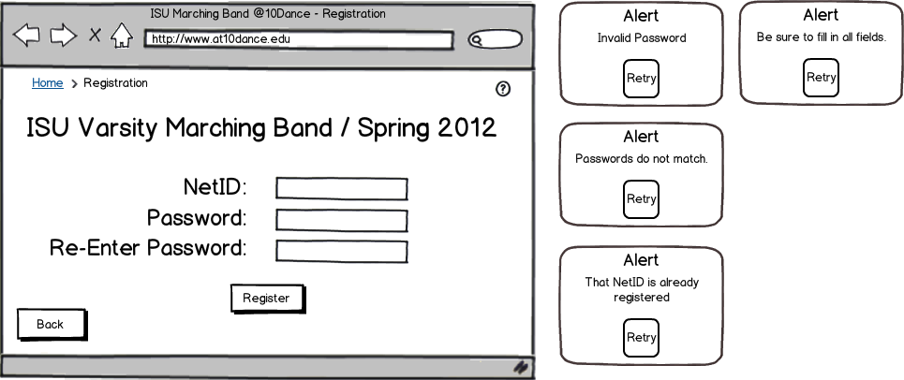

7_Student_Page

Sketch: Todd Wegter, Yifei Zhu

Annotations:

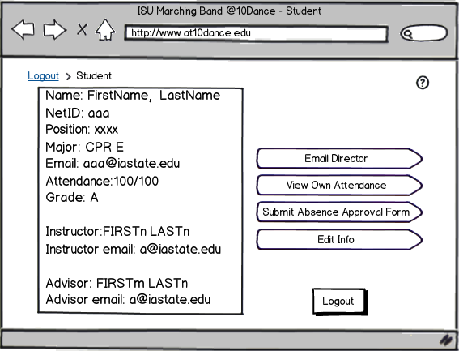

8_Student_Bar_Graph

Sketch: Todd Wegter, Yifei Zhu

Annotations:

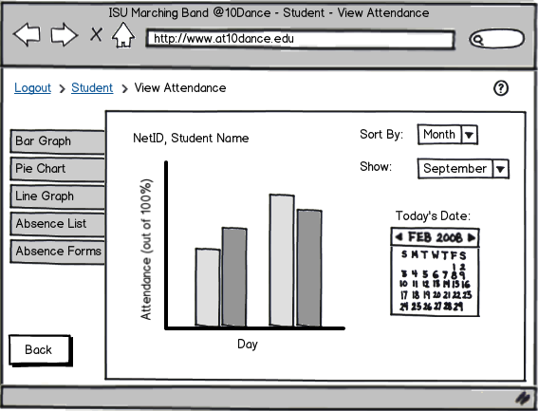

9_Student_Line_Graph

Sketch: Todd Wegter, Yifei Zhu

Annotations:

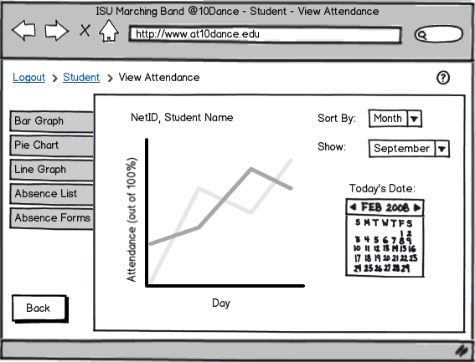

10_Student_Pie_Chart

Sketch: Todd Wegter, Yifei Zhu

Annotations:

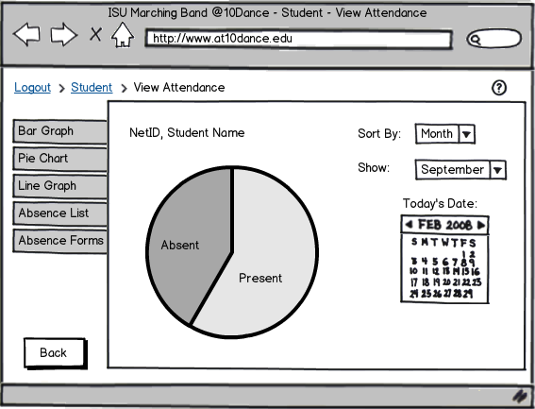

11_Student_Edit_Info

Sketch: Todd Wegter

Annotations:

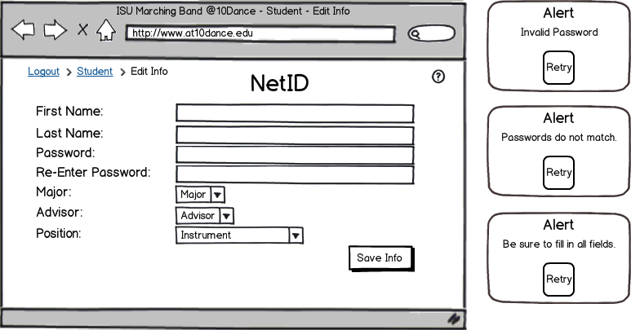

12_Student_Absence_Approval_Form

Sketch: Todd Wegter

Annotations:

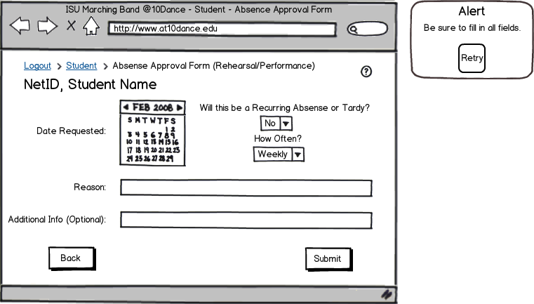

13_Student_Class_Conflict_Form

Sketch: Todd Wegter

Annotations:

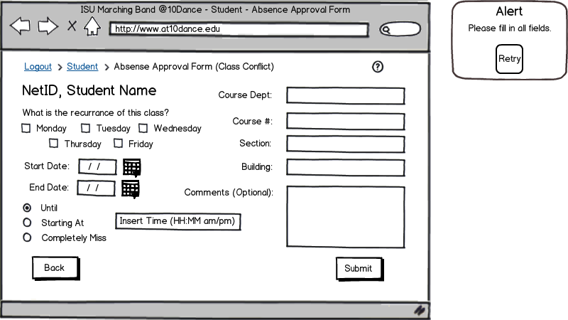

14_Studnet_Absence_Approval_Form_Type

Sketch: Todd Wegter, Yifei Zhu

Annotations:

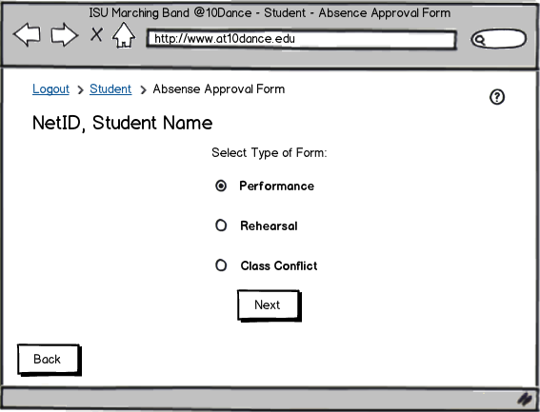

15_Director_Page

Sketch: Todd Wegter,Yifei Zhu

Annotations:

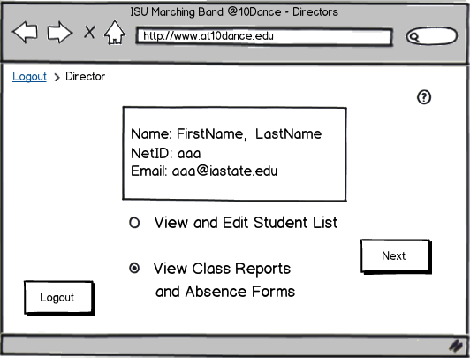

16_Director_Student_List

Sketch: Todd Wegter, Yifei Zhu

Annotations:

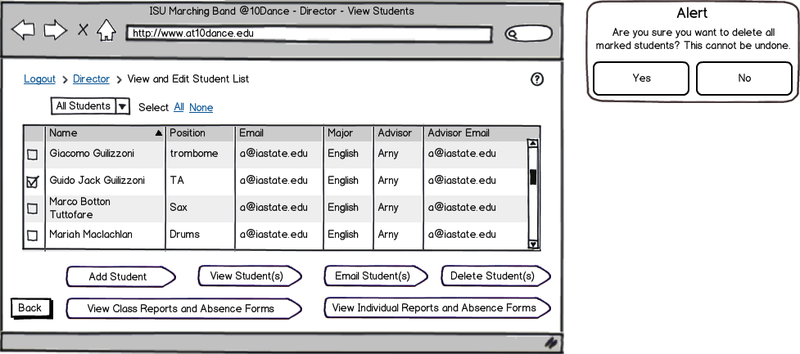

17_Director_Student_Add

Sketch: Todd Wegter

Annotations:

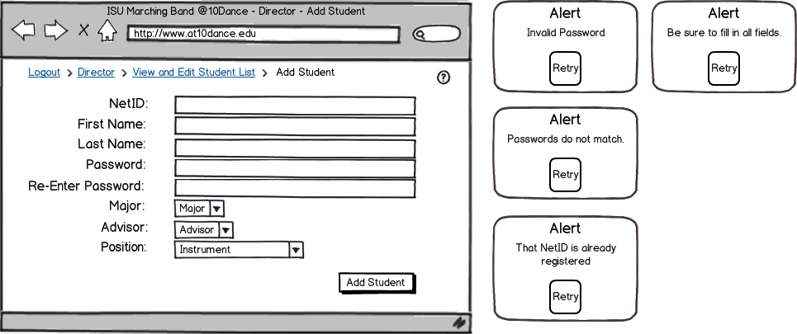

18_Director_Student_View

Sketch: Todd Wegter, Yifei Zhu

Annotations:

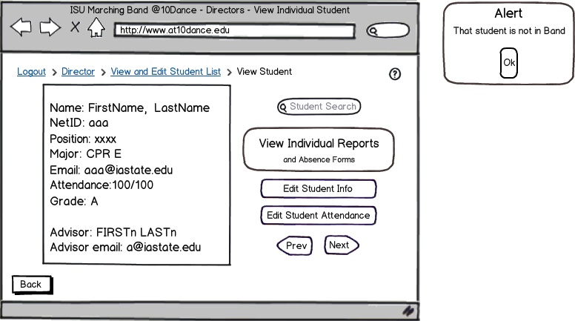

19_Director_Student_Edit_Info

Sketch: Todd Wegter

Annotations:

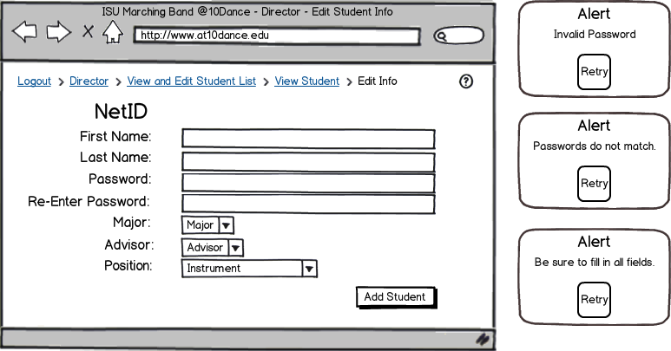

20_Director_Student_View_Report

Sketch: Todd Wegter, Yifei Zhu

Annotations:

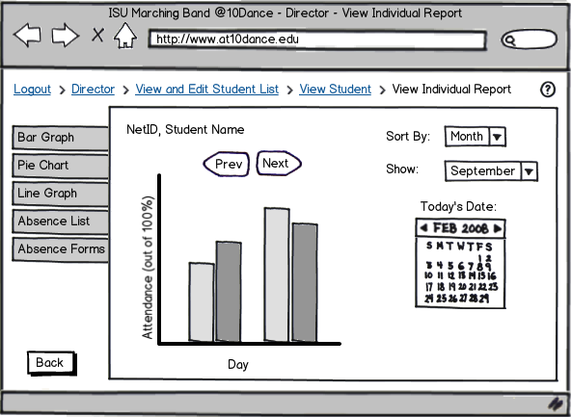

21_Director_View_Class_Report

Sketch: Todd Wegter, Yifei Zhu

Annotations:

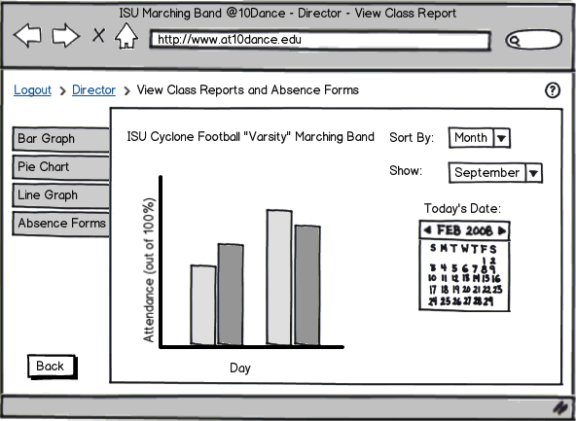

22_Director_Student_View_Absence

Sketch: Todd Wegter

Annotations:

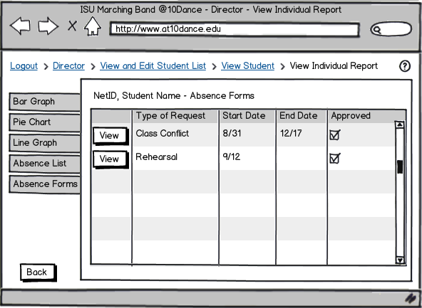

23_Director_View_Class_Absence

Sketch: Todd Wegter

Annotations:

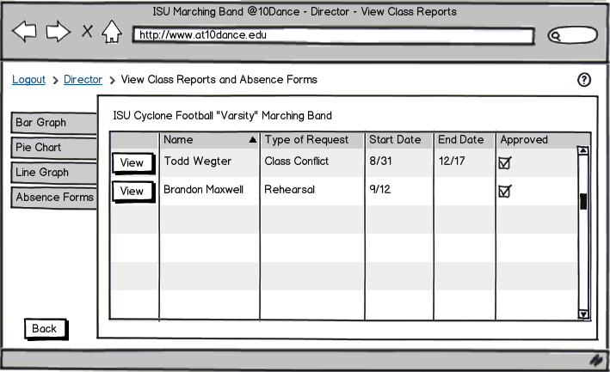

24_Director_Student_View_Forms

Sketch: Todd Wegter

Annotations:

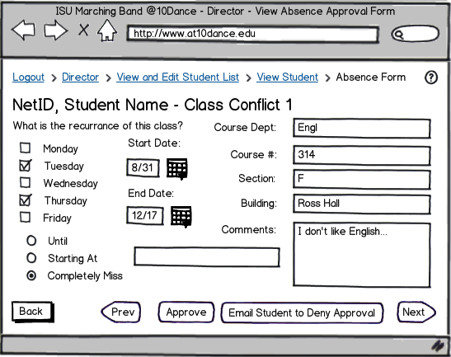

25_Director_Student_Absence_List

Sketch: Todd Wegter

Annotations:

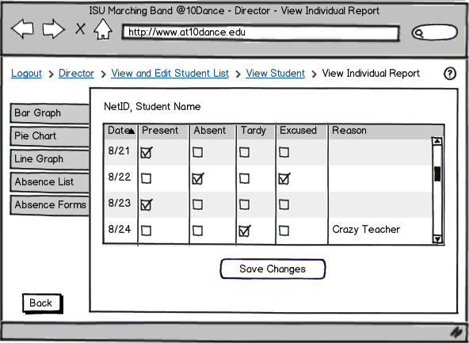

26_TA_Page

Sketch: Todd Wegter

Annotations:

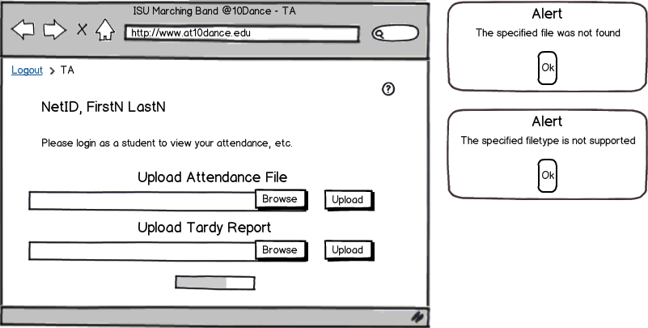

27_Help

Sketch: Todd Wegter

Annotations:

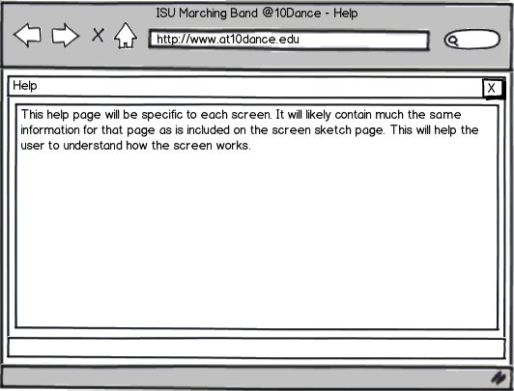

28_Student_View_Attendance_List

Sketch: Todd Wegter

Annotations:

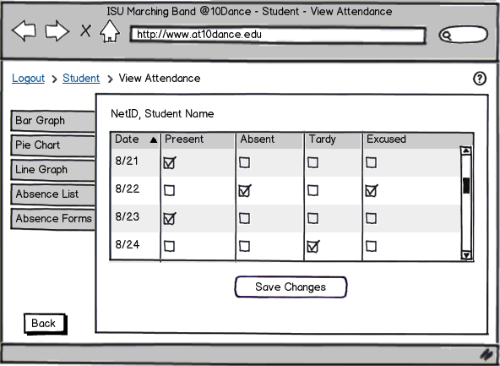

29_Student_Absence_Form_List

Sketch: Todd Wegter

Annotations:

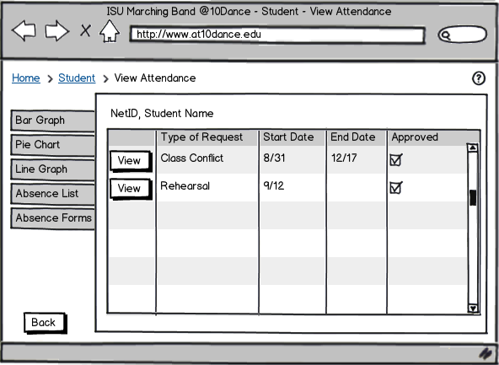

30_Director_View_Class_Forms

Sketch: Todd Wegter

Annotations:

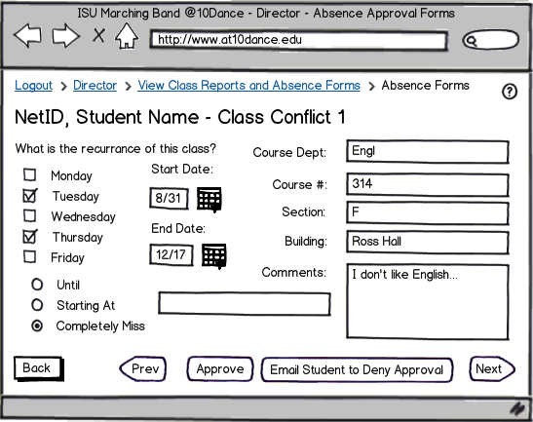

31_Student_View_Absence_Approval_Forms

Sketch: Todd Wegter

Annotations:

